**Activity Mode—GM 2.0**

1. **Mode Instruction**

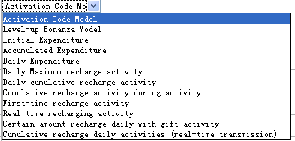

1. Activation code Model==set Activity code which player can use in game and get the gift.
2. Level-up Bonanza Model–when players reach the level you set and login the game during the date, they can get the gift
3. Initial Expenditure – First time to Spend diamonds in all servers.
4. A cumulated expenditure– Total usage during activity
5. Daily expenditure–Daily total usage
6. Daily Maximum recharge activity –
7. Daily cumulative recharge activity - - Daily total recharge.
8. Cumulative recharge activity during activity-- total recharge during activity
9. First-time recharging activity
10. Real-time recharging activity
11. Certain amount recharge daily with gift activity--cumulative
12. Cumulative recharge daily activities(real-time transmission)
13. **Using Instruction**

**2.1. Choose <Game world operations> 🡪 Activity Mode Setup- New, Click <add event>**

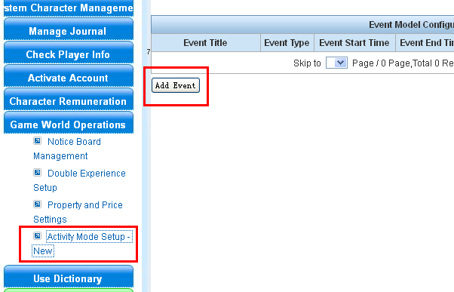

**2.2 Instruction by different activity type:**

**2.2.1. Add <** **Activation Code Model >:**

A. Event ID should be start with 11/15 and it should be 10bits. You can set like this 11+ year+ month+ date+ Num. Such as 1114042901.

Event type choose < Activation Code Model > and set the time 🡪 submit

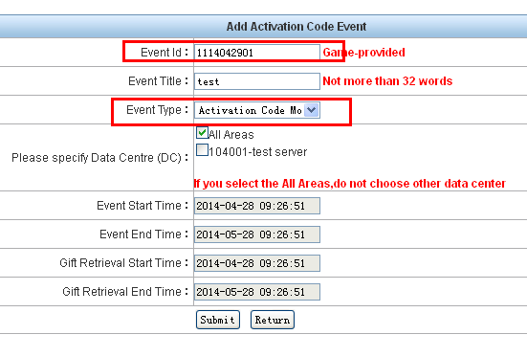

B. Click the <operation> button in list page.

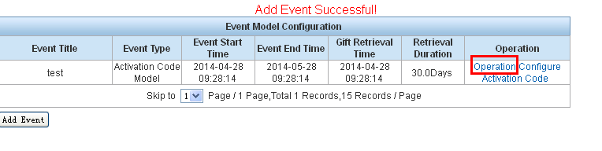

C. Click<configure Gift> into the set-gift page

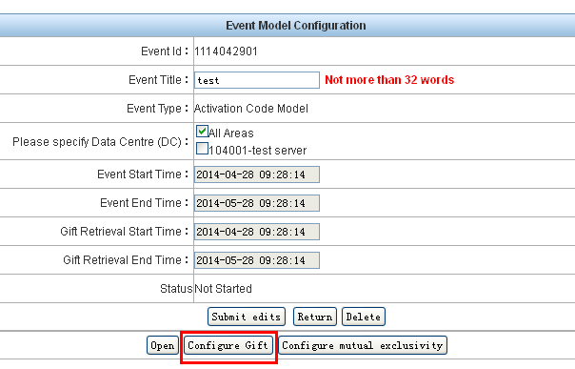

D. Limited level, Min level = 0 means everyone can get the gift. You can set the limited as your wish.

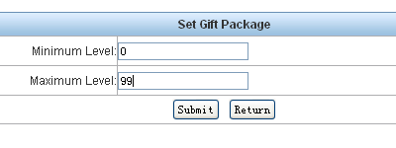

E. In the following page, you can set your gifts by click the button. You can set more than one item.

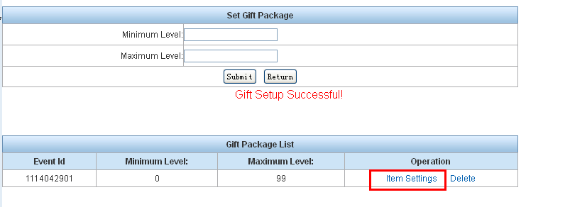 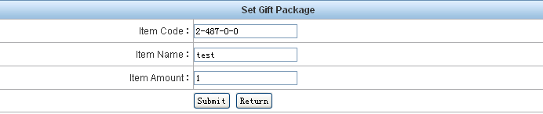

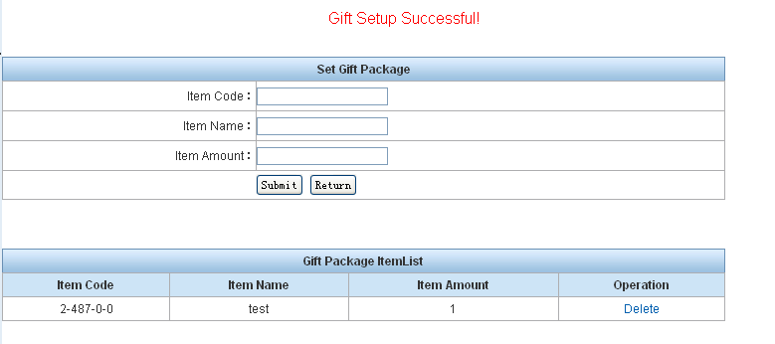

F. Back to activity list page after finished setting the gift. Click the button set code.

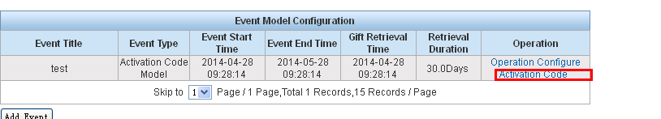

G. Set different numbers of code as your wish. Using times = 0 means can be used without limited. But each account can only use once in all servers.

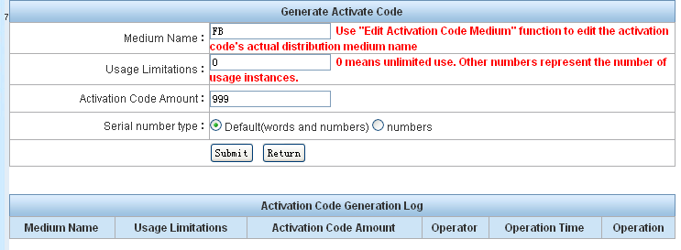

H. After all these. Go back to list page. Click <OPERATION> then choose <open>

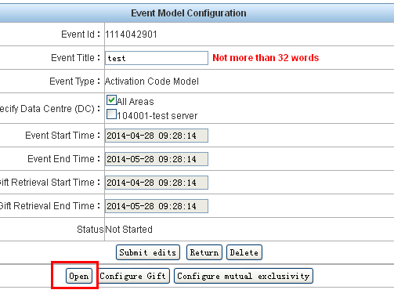

**2.2.2 Add < Level-up Bonanza Model >**

A. Set the <event type> to < Level-up Bonanza Model >，you have to set the create time of character.

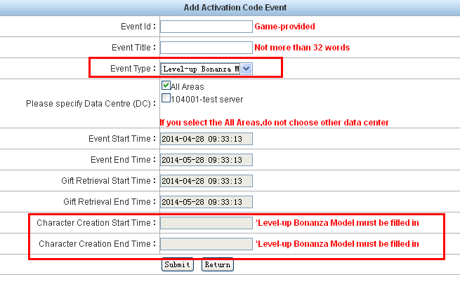

B. Click<operation> in list page.

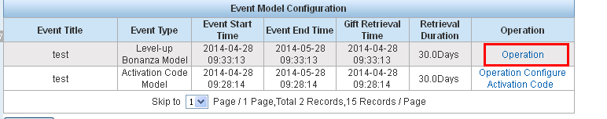

C. Choose <configure gift>。

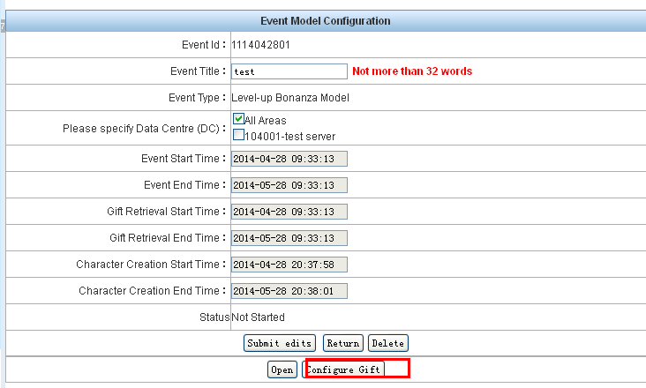

D. Limited level, Min level = 0 means everyone can get the gift. You can set the limited as your wish.

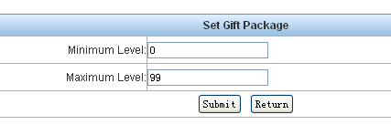

E. In the following page, you can set your gifts by click the button. You can set more than one item.

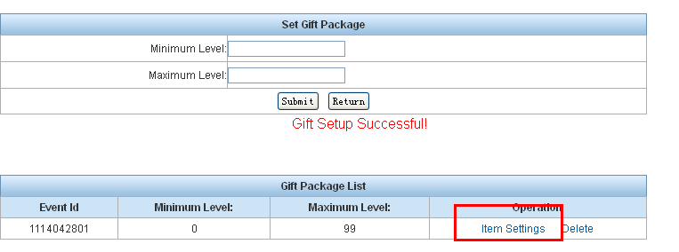

F. Back to activity list page after finished setting the gift. Click the<operation> button and choose <open>.

**2.2.3 Other activities.**

All other activities is the same as setting < Level-up Bonanza Model >

**三、 Change the events.**

1. If the event have not open, please get into <operation> and change what you need directly.

2. If the event is effect. This event cant been changed.

3. If the event is open, but not effect. Please close the event first.

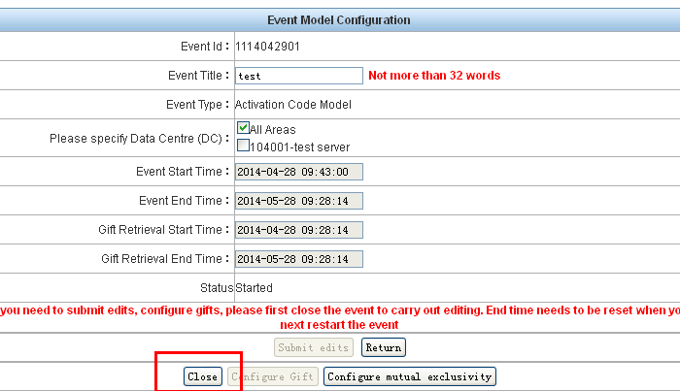4. Return to list page and do your change.

5. Be careful with the <Event End Time> after changed the gift. It needs to be changed before you can open the event.

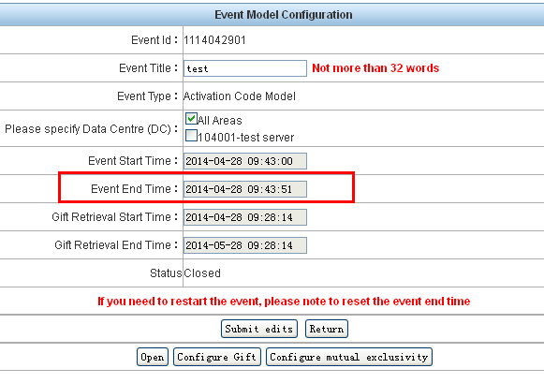

四. Delete event

1. If the event never has effect to server before, you can delete it on event page.

2. If the event has effect to server before, it can’t be delete.